**Project Design Phase**

**Solution Architecture**

|  |  |
| --- | --- |
| Date | 26 June 2025 |
| Team ID | LTVIP2025TMID37089 |
| Project Name | Sustainable Smart City Assistant using IBM Granite LLM |
| Maximum Marks | 4 Marks |

**Solution Architecture:**

**The Sustainable Smart City Assistant is a generative AI-based system powered by IBM Granite LLM, designed to provide intelligent support for urban governance and sustainability.**

**It features an interactive user interface built using Gradio, where users can log in, select assistant modes, and input natural language queries.**

**The backend logic, developed in Python, processes these inputs to perform tasks such as eco-guidance, civic complaint classification, and department routing.**

**The IBM Granite model is hosted via Hugging Face Transformers and supports high-performance inference on CPU or GPU. Deployment is handled through Gradio’s share feature or platforms like Google Colab, with scalability options using FastAPI or Hugging Face Spaces.**

**The system is modular and extensible, making it suitable for future enhancements such as energy monitoring, image integration, or chatbot expansion.**

**Example - Solution Architecture Diagram:**

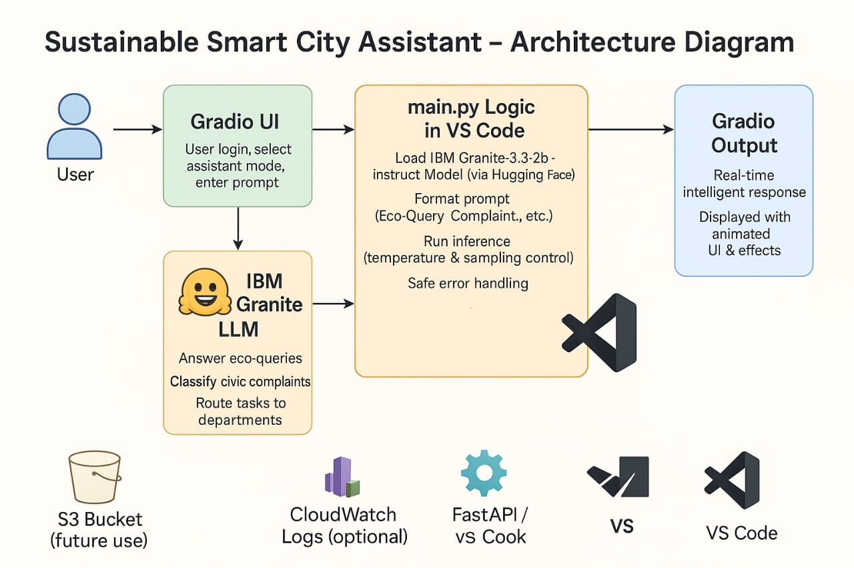

*Figure 1: Architecture and data flow of the* ***Smart City Assistant***